**1. Introduction**

**1.1] Introduction of website/system:**

In **Library Management system** Project website allows users to check for various information available on the books present in the library which are active and available to acquire. The project will consists of list of books displayed in table. If the user like to request any book related to syllabus he/she can request it. Also the project contain feedback form for all. Lastly the about us page which gives the information about project developer.

Here the project use php to make the entire data thus the library management system pages brings a fronted. Also mysql servers as a backend to store entire information.

XAMPP is used to create server and client on same device for checking purpose and to make things faster.

**Problem Definition**

If we go regular way journal needs to be maintained for the books record, we removed that option.

It is very difficult to identify the book present in the library or lost book.

Due to manual work load it makes hard to analyze and keep track of books

It also requires more space & time due to manual work report generation is to be delayed.

Updating existing stored data is difficult & time consuming.

**1.2 Existing System**

The current system for Library Management is to visit the shop manually and from the available book choose the book customer want. Also user can request a book which is not present in library.

* It is less user-friendly.
* User must go to Library and see for the book.
* It is difficult to identify the required Services
* It is a time consuming process
* Not in reach of distant users.

**1.3 Scope of the System**

The scope of work of “Library management system” involves studying existing system (manual) & simplifies complex manual system by using computerized system. 

In this computerized System all the activity which has been done manually are done with great reliability, accuracy & speed with the help of this software. 

* It stores records for larger period without any data loss. 
* It also accepts request.
* Taking feedback for further improvement.

**2. Proposed System**

**2.1 Objectives**

* To look for books in library without physically surfing.
* To maintain book records
* To give the absolute information of books and in minimum time.
* To categorize available books

**Benefits:**

* **User Friendliness:**

This project has user-friendly screens designed will have very simple functionality for the information.

* **Consistency:**

The consistency in the proposed system will high efficiency due to smaller learning curves and increased data integrity.

* **Compatibility:**

This project offers great compatibility, as it will be designed with proper methodology, new tools and technology.

* **Security:**

This project is secured system, which will provide corporate level security. Also that will enable a user to view/edit/add the information, based on roles and privilege assigned to that user.

* **Reliability & Robustness:**

This project built with proper architecture and design it will provide a reliable and robust application to the user.

* **Performance:**

The performance of this application will be high because of it is optimize design.

* **Extensibility:**

This project has a modules design and would provide the flexibility of adding, future modules to the application

**Feasibility Study**

Feasibility study is essential to evaluate cost & benefit of the Proposed system. This is very important step because on the basis of this; system decision is taken on whether to proceed or to postpone the project or to cancel the project. We first study existing system and identify all problems & Look Into three types of feasibility study, those are given below:

**1. Technical feasibility:**

The project work can be done with the present equipment, current procedures, existing software technology and available personnel. The available system i.e. computer, hardware & software availability, support facilities, operating time etc. is technically perfect to fit the scenario.

It is compatible with technical skills of the organization. Technical issues usually rise during the feasibility stage of investigation include the following:

* Dose the necessary technology exists to do what is suggested?
* Can system be expended if developed?
* Are technical guarantees of accuracy, reliability ease of access and data security?

**2. Operational Feasibility:**

The advantage of the system is that is reduced the tedious manual work & also the long times required achieving optimum result due to manual work.

The proposed system is feasible enough to operate. The developed only if they can be turned into information system that will meet organization operating requirements.

This test of feasibility asks if the system will work when it is developed and installed. Are there major barriers to implementation? A new comer also handles the system after getting some guidelines.

**3. Economic Feasibility:**

The one cost like feasibility study cost, cost for converting from Present system to new system and recurring costs like printers, equipment maintenance falls within the budget of the management.

All the persons that are working in the bank have the primary knowledge about computer, so that training period as well as the amount required for the training is in the budget.

Hence the system is economically feasible.

**2.2 Requirement Engineering**

**2.2.1 Requirement Gathering**

Requirements gathering is an important part of project planning. Whether you’re interviewing stakeholders or performing other types of research to compile your list of project requirements, having project management software that can hold all your information and seamlessly move it into the next phase will go a long way.

When your stakeholders and your team members share access, you can communicate and collaborate from project start to finish and reduce any chance of setbacks.

**HARDWARE REQUIREMENTS:**

|  |  |
| --- | --- |
| **1. PROCESSOR** | **:Pentium 4 & above** |
| **2. RAM** | **:1 GB & above** |
| **3. HARD DISC SPACE** | **:120 GB & above** |
| **4. DISPLAY UNIT** | **:Monitor or LCD** |

**2.2.2 SOFTWARE REQUIREMENTS:**

* **WAMP Server**
* **XAMPP Server**

**Front End:**

* **HTML** 
* **CSS** 
* **JavaScript**

**Back End:**

* **PHP** 
* **MySQL**
* **Ajax**

### 3. System Analysis

**System Diagram**

**3.1 DFD**

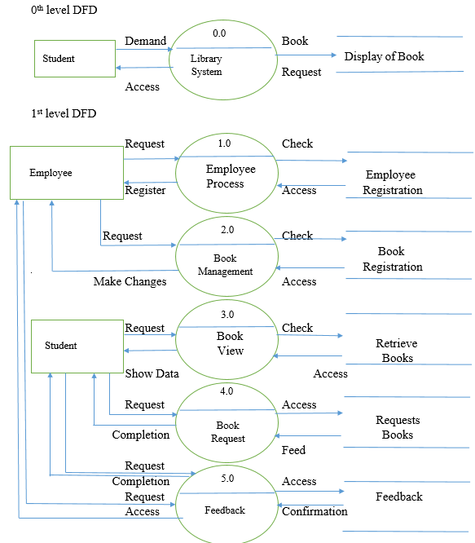

**3.2 ERD**

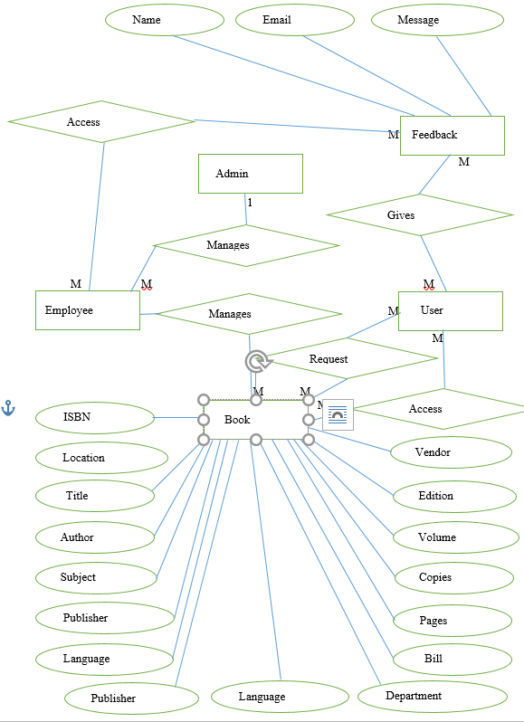

**3.3 Site Map**

**4. System Design**

**4.1 Database Design**

* Table Name : sheet1

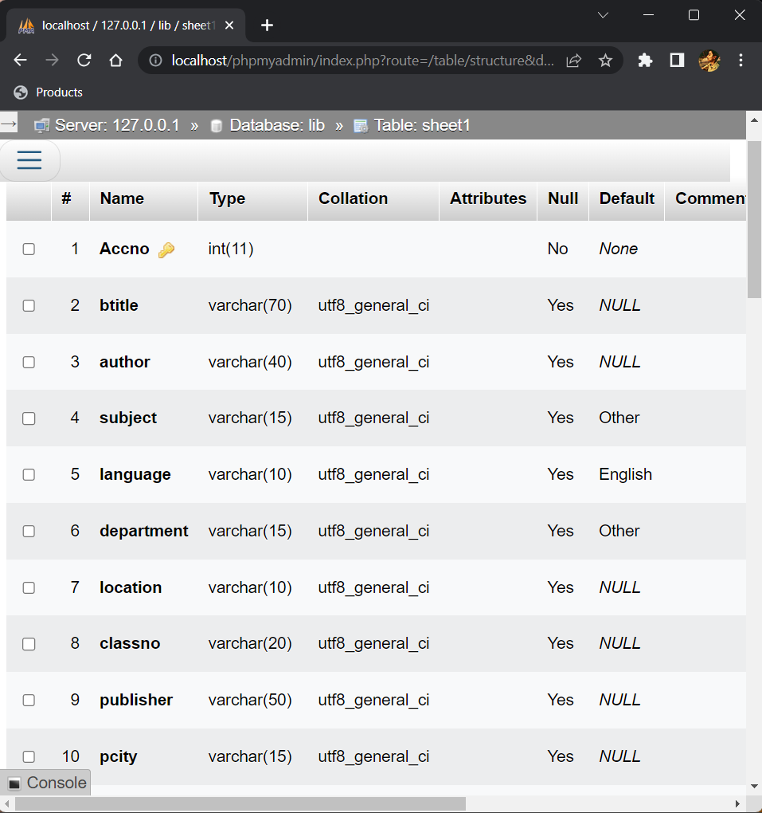

* Table Name : feedback

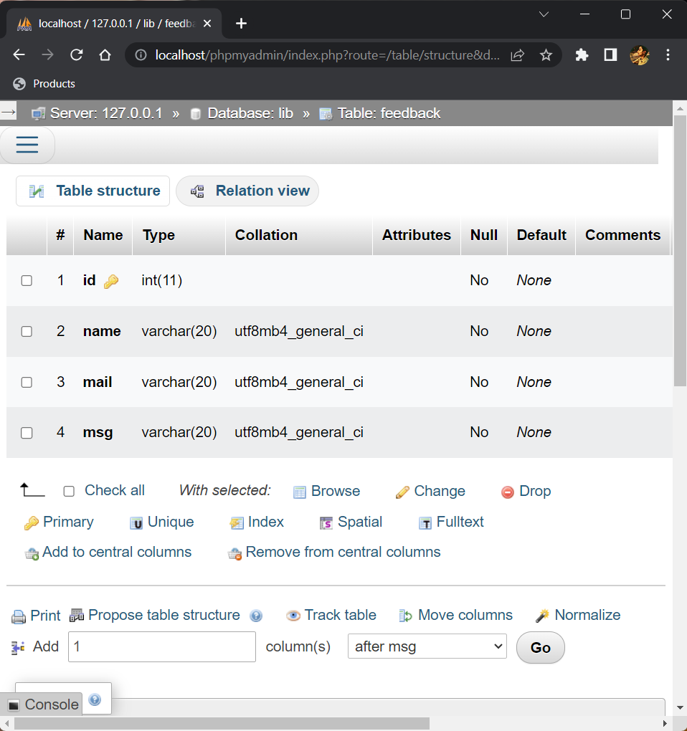

* Table Name : registration

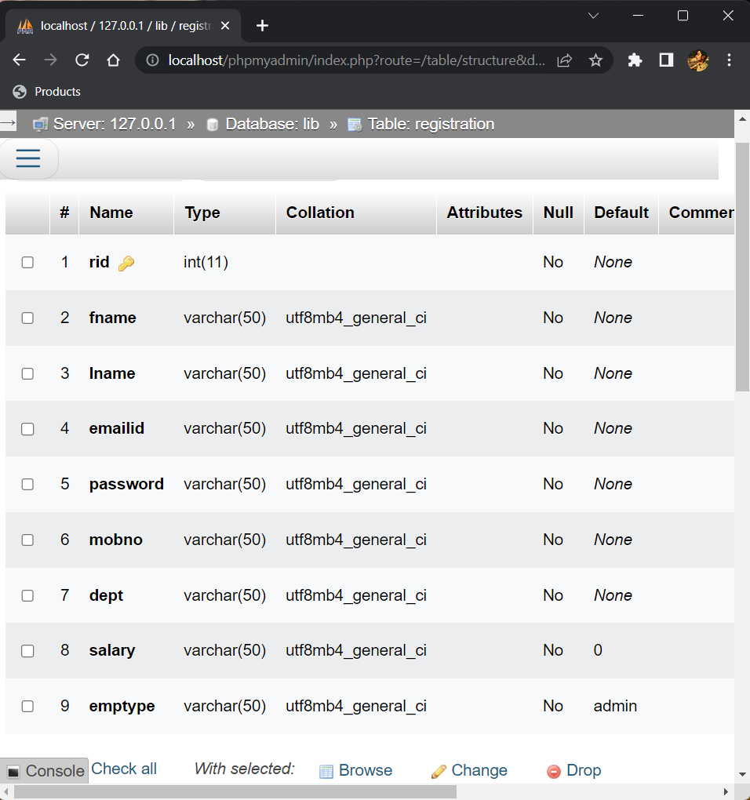

* Table Name : reqbook

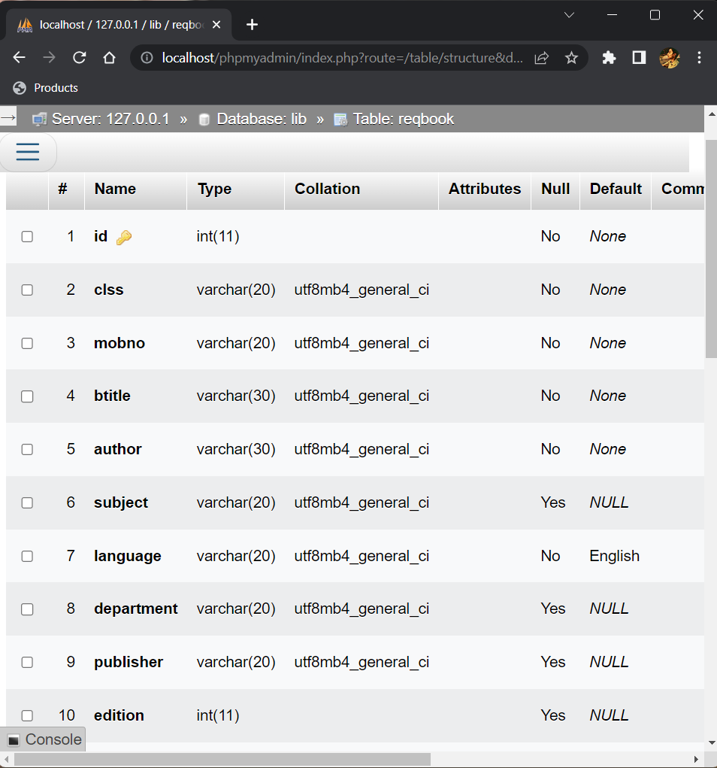

**4.2 Input Design**

* **Employee Login**

**Path:** Home/Employee/Login

**Description:** Login page specially designed for employee. Emailid and password are required to login to the employee page

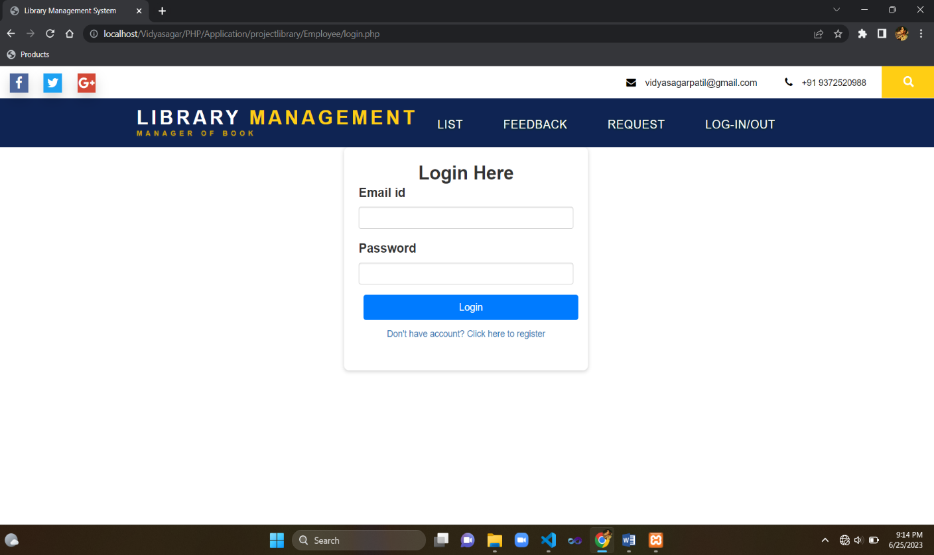

On successful alert as Successful

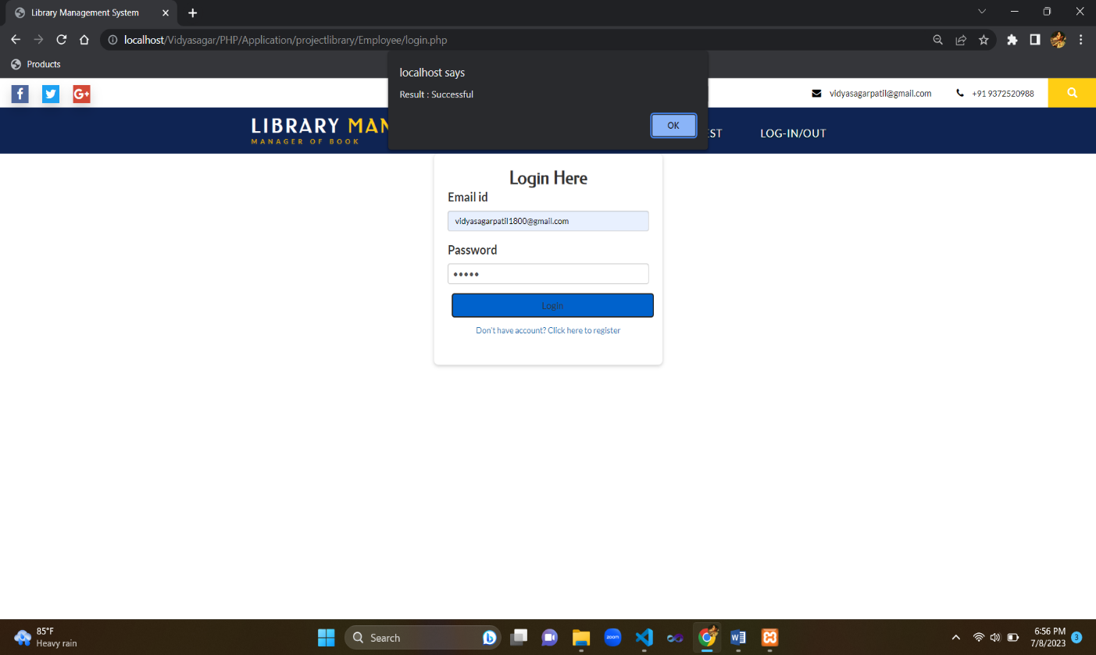

**Employee Registration**

**Path:** Home/Employee/Register

**Description:** Page for registration of new employee.

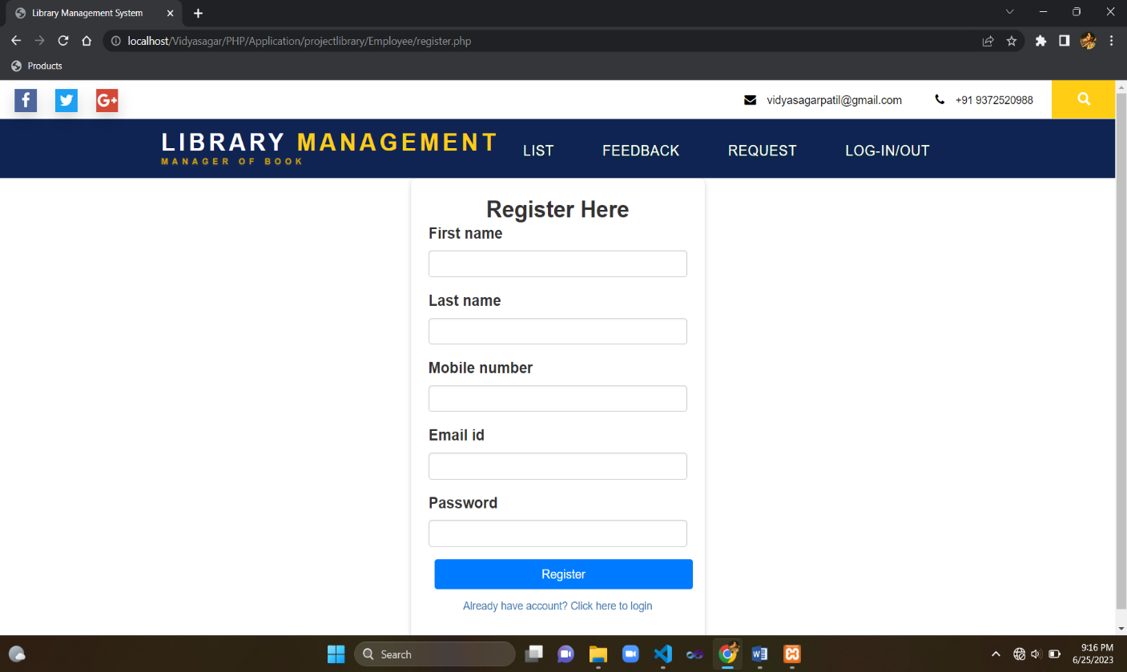

**Validation:**

All fields are compulsory. All fields have validation.

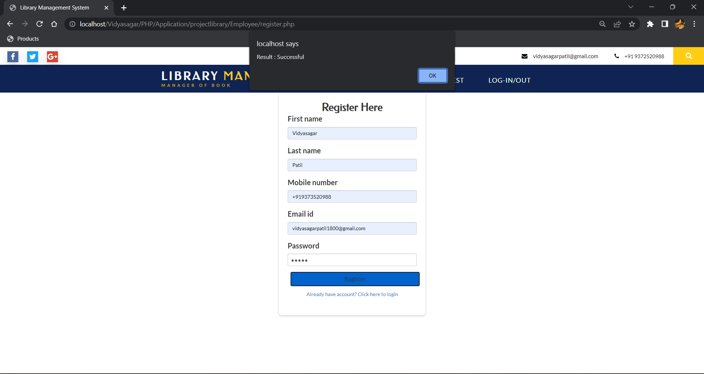

**Update Book**

**Path:** Home/Employee/Dashboard/Update

**Description:** Page for updating existing book record. All fields are not compulsory. Existing book can be updated.

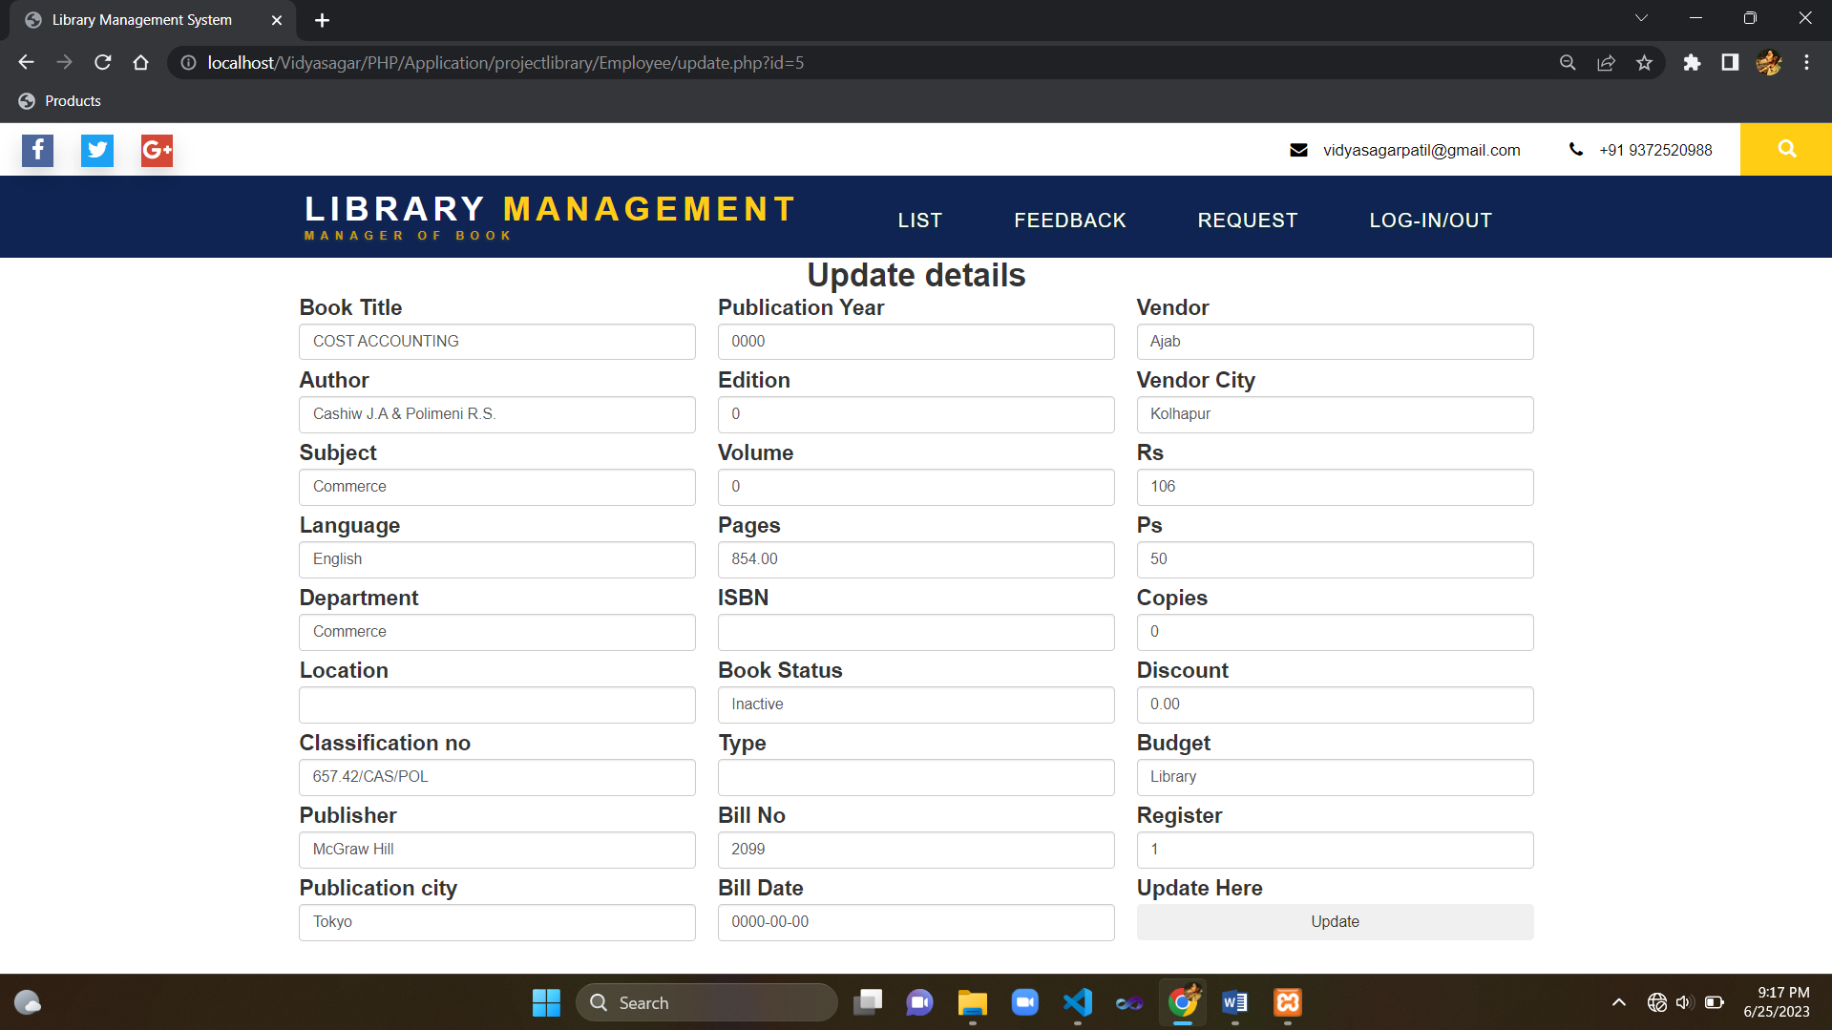

After updating the alert box is shown for successful updation.

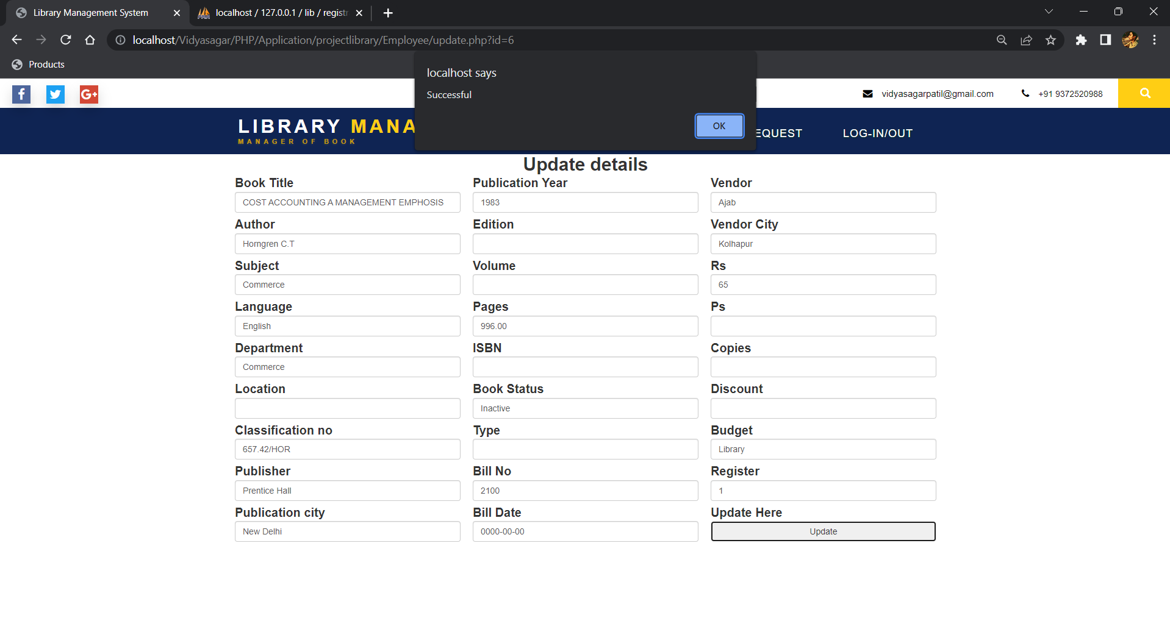

* **Request Book**

**Path:** Home/Employee/Update

**Description:** Page for requesting book of any type. Employee can check the request.

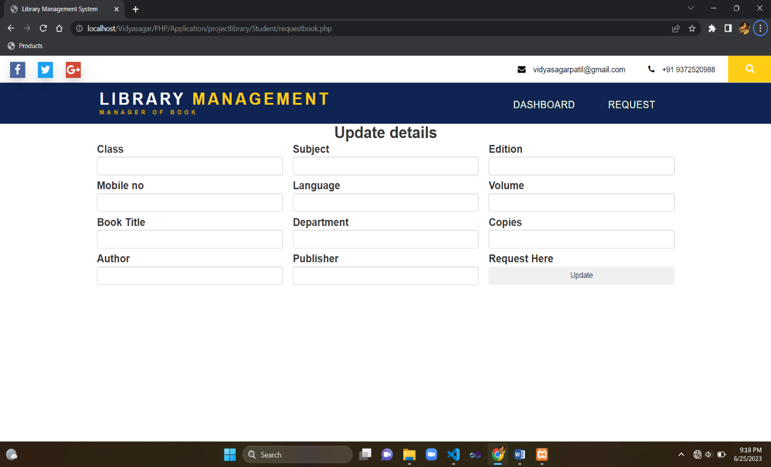

On successful submition

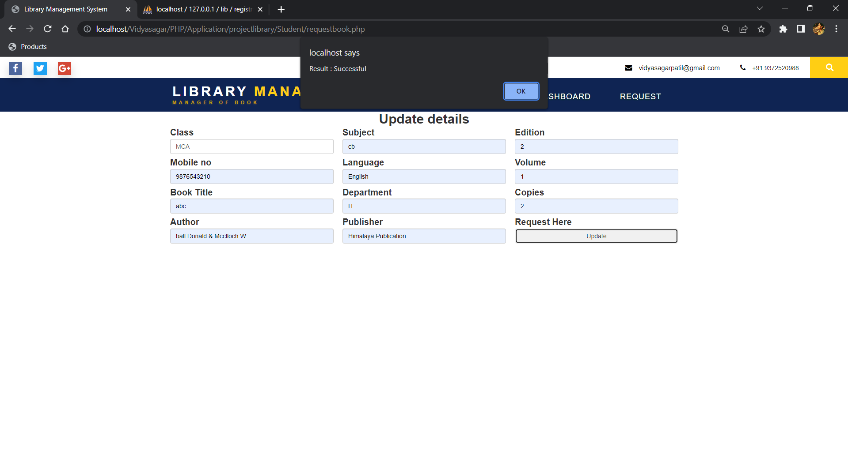

* **Feedback Form**

**Path:** Home/Feedback

**Description:** Page for giving feedback

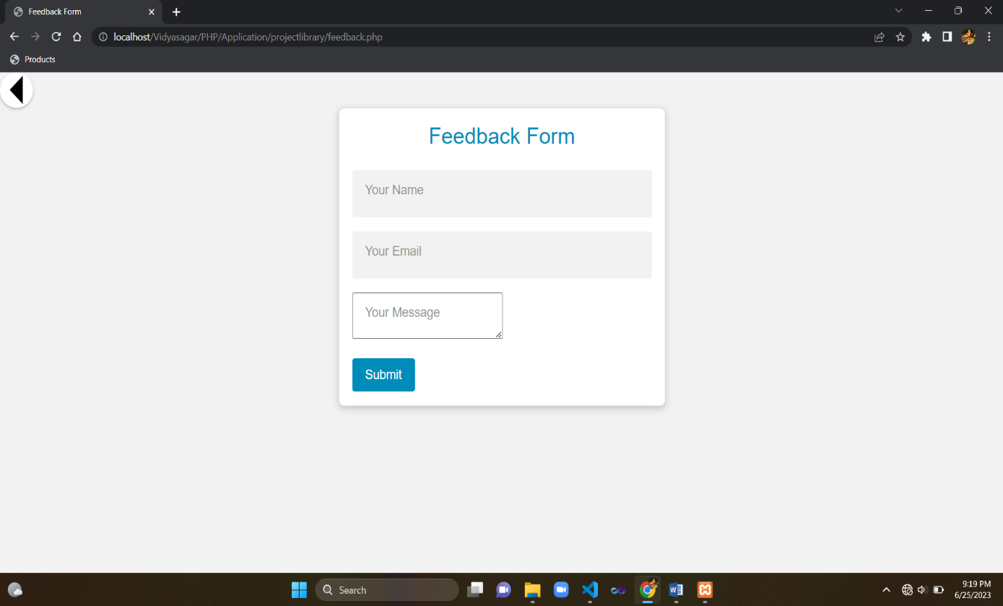

On submission

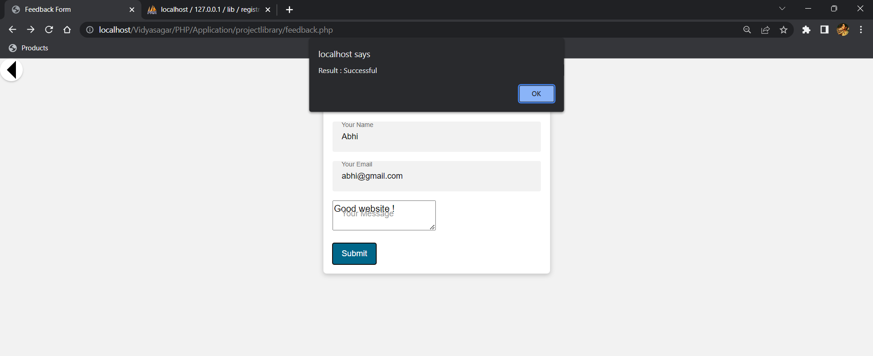

**4.3 Output Design**

* **Home**

**Path:** Home

**Description:** Main page dividing two users from each other.

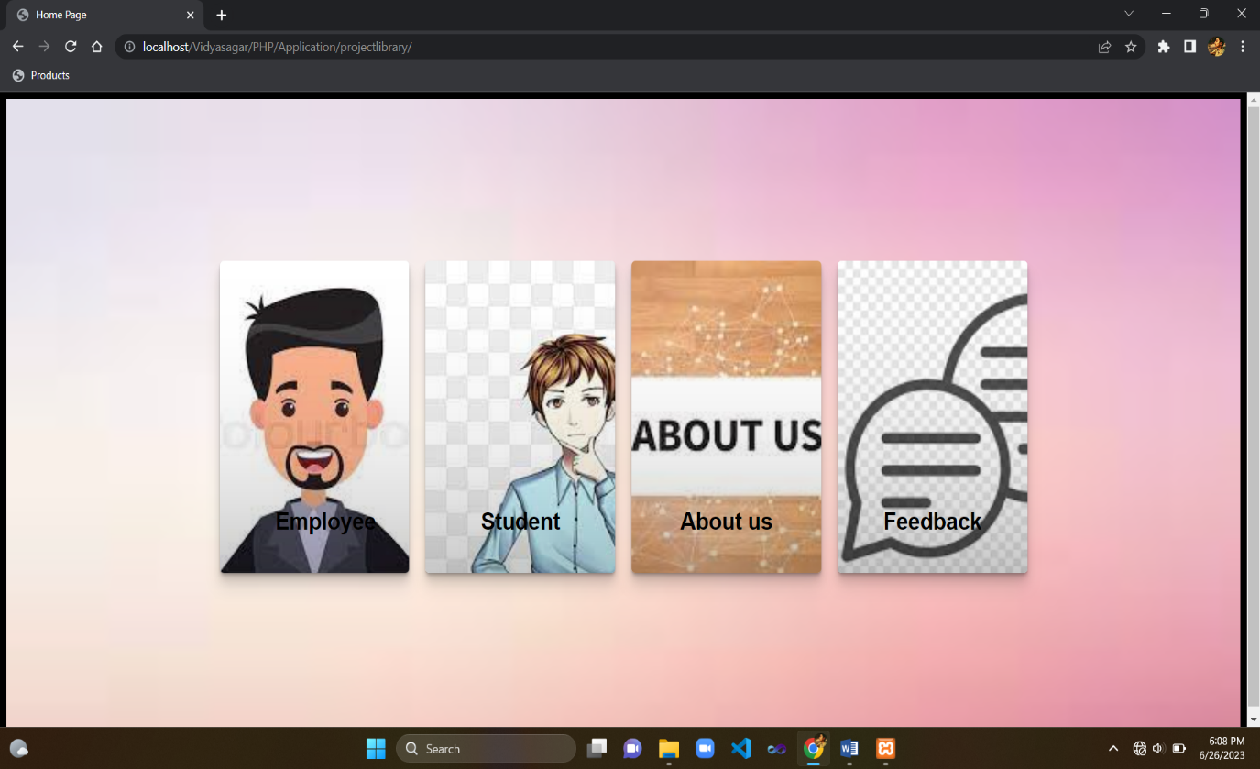

On moving cursor on any template

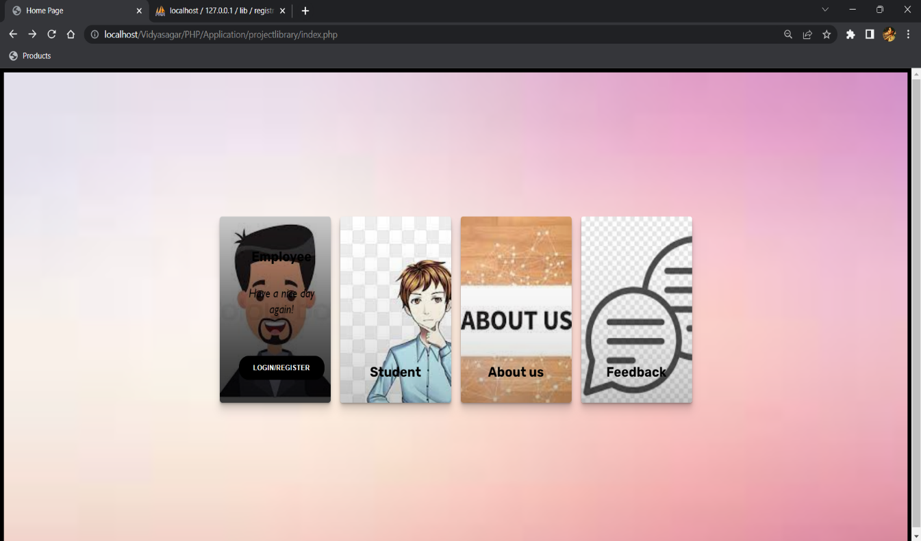

* **Admin Home(Dashboard)**

**Path:** Home/Dashboard

**Description:** Page showing all books records with book title, author, subject, language, pages, and its price. The books can be made active/Inactive through the status block. The books are also can be updated and deleted.

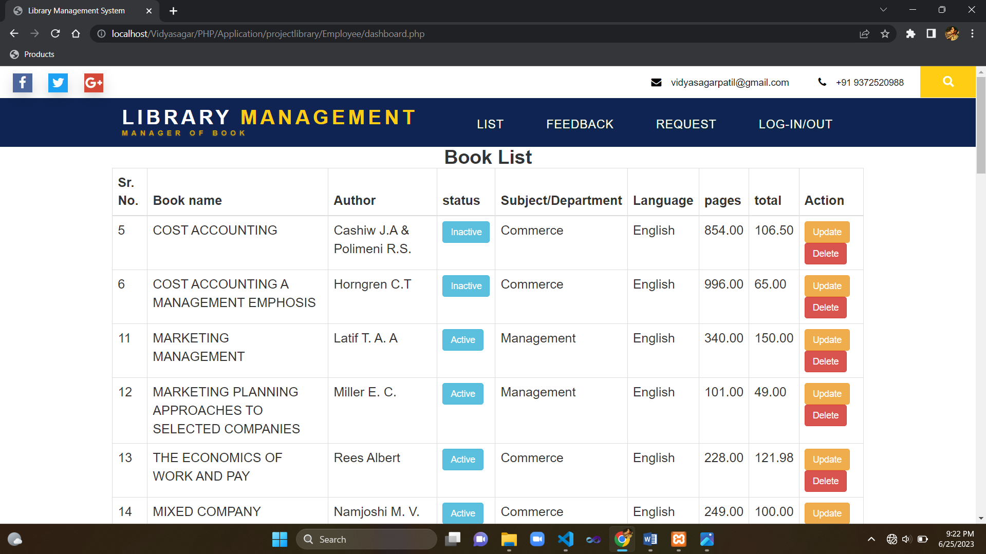

* **User Home(Dashboard)**

**Path:** Home/User/Dashboard

**Description:** Page for showing all available books in library. The books shown are the only one that are active at current time.

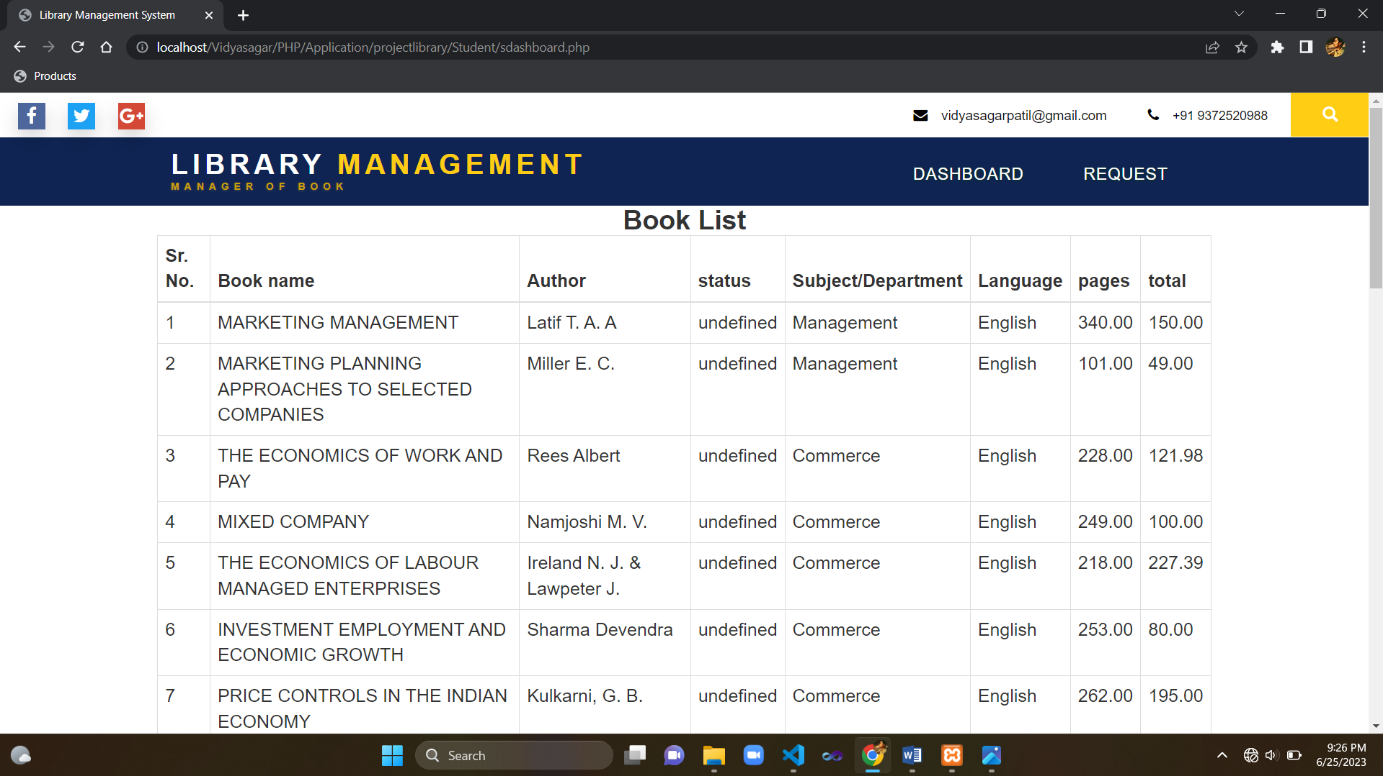

* **About Us**

**Path:** Home/About

**Description:** Page showing about information of the admin. Email,phone no., and address are provided for contact.

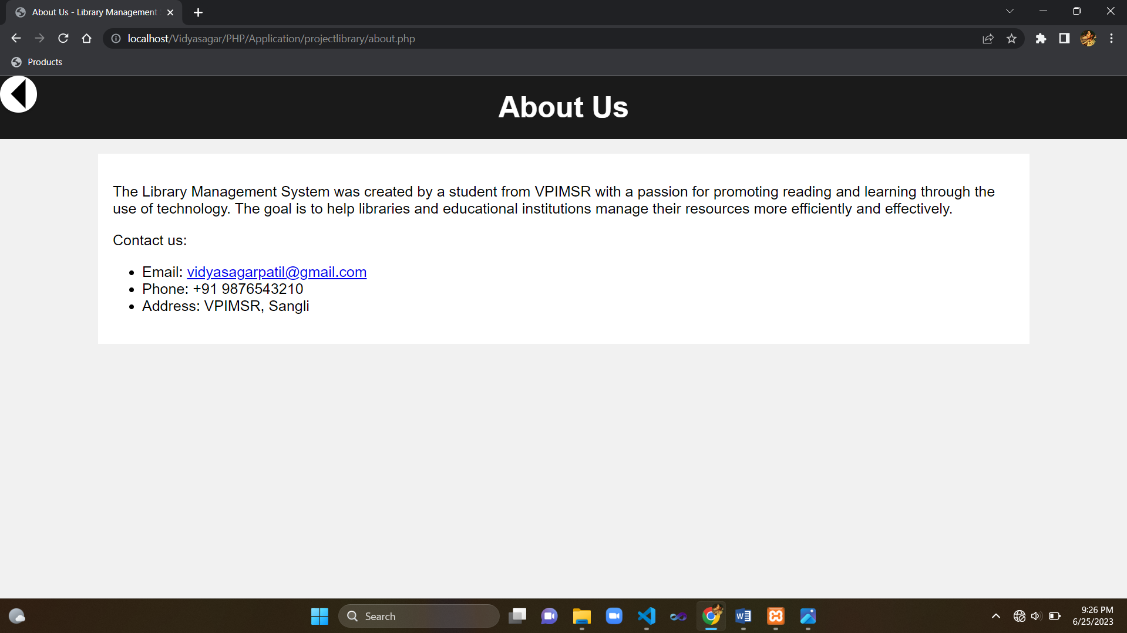

**5. Reports**

* **Feedback**

**Path:** Home/Employee/Feedback

**Description:** Page showing all received feedback of the users. This page is shown to employee only.

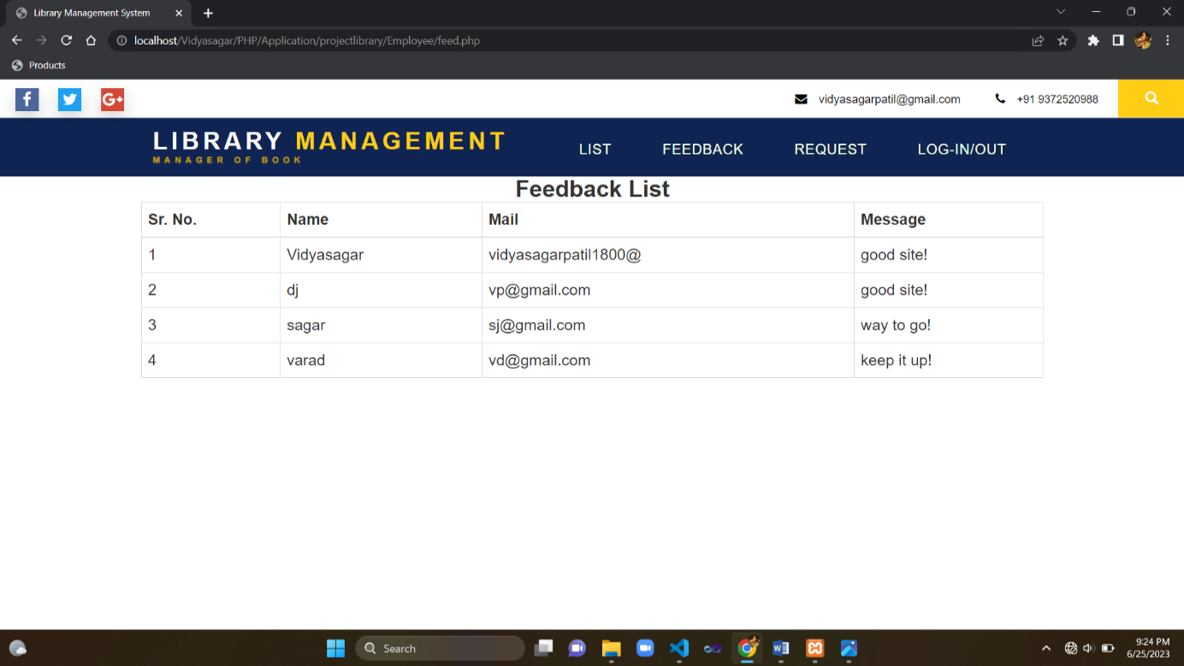

* **Requests**

**Path:** Home/Employee/Request

**Description:** Page for showing all received request. Employee can delete unnecessary requests from this report.

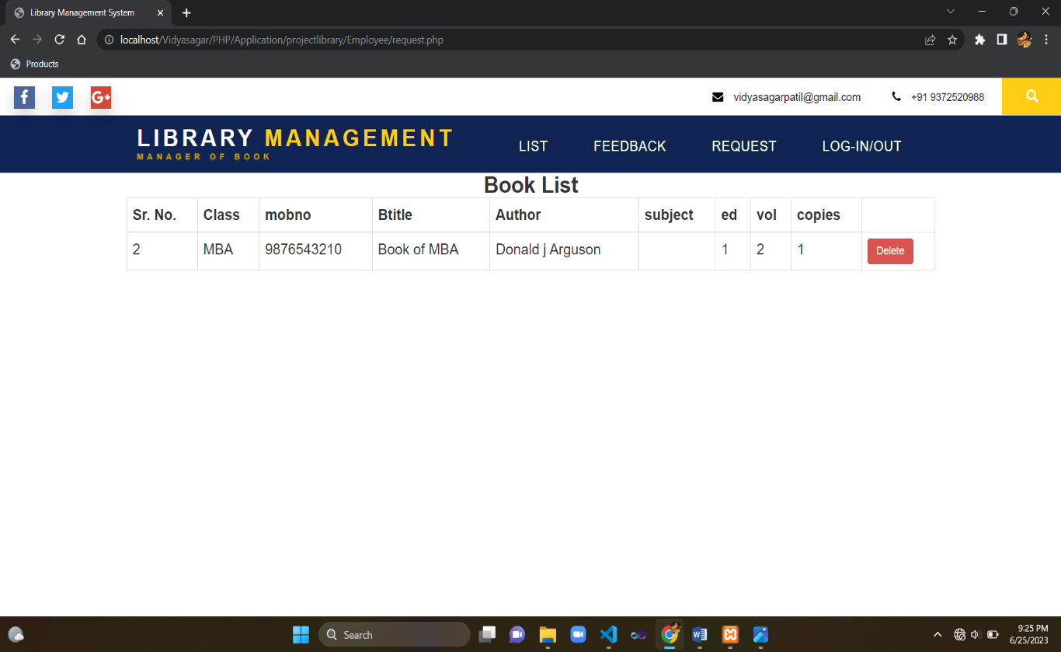

**6. Conclusion & Suggestions**

**6.1 Conclusion**

The Library Management System is online system which provides information about **books** and enables users to search information about books. It makes the user easy to request a book. Instead of wasting a lot of time to see or find the information of books. This website is developed to achieve maximum efficiency in maintaining the books offline and to reduce the time taken to register a book. In this website we provide them information which categorized into many parts.

**6.2 Limitations**

* Books cannot be borrowed through site
* Not much secure website
* Verification code facility has not been implemented
* Non adaptive
* Static pages are more than dynamic pages

**6.3 Suggestions**

* I will try to add book borrowing option in future.
* I will try to add Encoding decoding of the data
* I will try to add verification code at the time of create account in future.
* I will make my site adaptive in various server
* I will add more input pages and other functionalities

**7. References**

**7.1 Books**

* None

**7.2 Web**

* [www.w3schools.com](http://www.w3schools.com)
* [**https://getbootstrap.com**](https://getbootstrap.com)

**8. Annexure**

* **Source Code**
* **index.php**

<!DOCTYPE html>

<html lang="en" >

<head>

<meta charset="UTF-8">

<title>Home Page</title>

<meta name="viewport" content="width=device-width, initial-scale=1">

<link rel="stylesheet" href="style.css">

<style>

body {

background-image: url("icon/bg.jpg");

background-repeat: no-repeat;

background-size: cover;

}

</style>

</head>

<body>

<!-- partial:index.partial.html -->

<main class="page-content">

<div class="card">

<div class="content">

<h1 class="title">Employee</h1>

<p class="copy">Have a nice day again!</p>

<a href="Employee/login.php"><button class="btn">Login/Register</button></a>

</div>

</div>

<div class="card">

<div class="content">

<h1 class="title">Student</h1>

<p class="copy">See available books</p>

<a href="Student/sdashboard.php"><button class="btn">Dashboard</button></a>

</div>

</div>

<div class="card">

<div class="content">

<h1 class="title">About us</h1>

<p class="copy">Wanna know about us?</p>

<a href="about.php"><button class="btn">Take a Look!</button></a>

</div>

</div>

<div class="card">

<div class="content">

<h1 class="title">Feedback</h1>

<p class="copy">We always look for better opportunities to look forward</p>

<a href="feedback.php"><button class="btn">Go ahead-></button></a>

</div>

</div>

</main>

<!-- partial -->

</body>

</html>

* **MyTemplate.php**

<?php

class MyTemplate

{

var $top;

var $header;

var $footer;

function __construct()

{

$this->top='

<!DOCTYPE html>

<html lang="en">';

$this->header='

<!--Header-->

<head>

<title>Library Management System</title>

<!-- for-mobile-apps -->

<meta name="viewport" content="width=device-width, initial-scale=1">

<meta http-equiv="Content-Type" content="text/html; charset=utf-8" />

<meta name="keywords" content="" />

<!-- for-mobile-apps -->

<link href="../css/bootstrap.css" rel="stylesheet" type="text/css" media="all" />

<!-- social media -->

<link href="../css/font-awesome.css" rel="stylesheet">

<!-- look -->

<link href="../css/style.css" rel="stylesheet" type="text/css" media="all" />

<!--fonts-->

<link href="//fonts.googleapis.com/css?family=Oswald:300,400,700" rel="stylesheet">

<link href="//fonts.googleapis.com/css?family=Federo" rel="stylesheet">

<link href="//fonts.googleapis.com/css?family=Lato:300,400,700,900" rel="stylesheet">

</head>

<body>

<!-- header -->

<div class="banner-top">

<div class="social-bnr-agileits">

<ul class="social-icons3">

<li><a href="https://www.facebook.com/" class="fa fa-facebook icon-border facebook"> </a></li>

<li><a href="https://twitter.com/" class="fa fa-twitter icon-border twitter"> </a></li>

<li><a href="https://plus.google.com/u/0/" class="fa fa-google-plus icon-border googleplus"> </a></li>

</ul>

</div>

<div class="contact-bnr-w3-agile">

<ul>

<li><i class="fa fa-envelope" aria-hidden="true"></i><a href="mailto:vidyasagarpatil@gmail.com">vidyasagarpatil@gmail.com</a></li>

<li><i class="fa fa-phone" aria-hidden="true"></i>+91 9372520988</li>

<li class="s-bar">

<div class="search">

<input class="search_box" type="checkbox" id="search_box">

<label class="icon-search" for="search_box"><span class="glyphicon glyphicon-search" aria-hidden="true"></span></label>

<div class="search_form">

<form action="#" method="post">

<input type="search" name="Search" placeholder=" " required=" " />

<input type="submit" value="Search">

</form>

</div>

</div>

</li>

</ul>

</div>

<div class="clearfix"></div>

</div>

<div class="w3_navigation">

<div class="container">

<nav class="navbar navbar-default">

<div class="navbar-header navbar-left">

<button type="button" class="navbar-toggle collapsed" data-toggle="collapse" data-target="#bs-example-navbar-collapse-1">

<span class="sr-only">Toggle navigation</span>

<span class="icon-bar"></span>

<span class="icon-bar"></span>

<span class="icon-bar"></span>

</button>

<h1><a class="navbar-brand" href="../index.php">Library <span>Management</span><p class="logo_w3l_agile_caption">Manager of book</p></a></h1>

</div>

<div class="collapse navbar-collapse navbar-right" id="bs-example-navbar-collapse-1">

<nav class="menu menu--iris">

<ul class="nav navbar-nav menu__list">

<li class="menu__item "><a href="dashboard.php" class="menu__link">List</a></li>

<li class="menu__item"><a href="feed.php" class="menu__link">Feedback</a></li>

<li class="menu__item"><a href="request.php" class="menu__link">Request</a></li>

<li class="menu__item"><a href="logout.php" class="menu__link">Log-in/out</a></li>

</ul>

</nav>

</div>

</nav>

</div>

</div>

<a href="#" id="toTop" style="display: block;"> <span id="toTopHover" style="opacity: 1;"> </span></a>

<script src="../js/bootstrap.js"></script>

</body>';

$this->footer='

<!-- Footer -->

<script src="../js/bootstrap.js"></script>

</html>';

}

}

?>

* **StudTemplate.php**

<?php

class StudTemplate

{

var $top;

var $header;

var $footer;

function __construct()

{

$this->top='

<!DOCTYPE html>

<html lang="en">';

$this->header='

<!--Header-->

<head>

<title>Library Management System</title>

<!-- for-mobile-apps -->

<meta name="viewport" content="width=device-width, initial-scale=1">

<meta http-equiv="Content-Type" content="text/html; charset=utf-8" />

<meta name="keywords" content="" />

<!-- for-mobile-apps -->

<link href="../css/bootstrap.css" rel="stylesheet" type="text/css" media="all" />

<!-- social media -->

<link href="../css/font-awesome.css" rel="stylesheet">

<!-- look -->

<link href="../css/style.css" rel="stylesheet" type="text/css" media="all" />

<!--fonts-->

<link href="//fonts.googleapis.com/css?family=Oswald:300,400,700" rel="stylesheet">

<link href="//fonts.googleapis.com/css?family=Federo" rel="stylesheet">

<link href="//fonts.googleapis.com/css?family=Lato:300,400,700,900" rel="stylesheet">

<!--//fonts-->

</head>

<body>

<!-- header -->

<div class="banner-top">

<div class="social-bnr-agileits">

<ul class="social-icons3">

<li><a href="https://www.facebook.com/" class="fa fa-facebook icon-border facebook"> </a></li>

<li><a href="https://twitter.com/" class="fa fa-twitter icon-border twitter"> </a></li>

<li><a href="https://plus.google.com/u/0/" class="fa fa-google-plus icon-border googleplus"> </a></li>

</ul>

</div>

<div class="contact-bnr-w3-agile">

<ul>

<li><i class="fa fa-envelope" aria-hidden="true"></i><a href="mailto:vidyasagarpatil@gmail.com">vidyasagarpatil@gmail.com</a></li>

<li><i class="fa fa-phone" aria-hidden="true"></i>+91 9372520988</li>

<li class="s-bar">

<div class="search">

<input class="search_box" type="checkbox" id="search_box">

<label class="icon-search" for="search_box"><span class="glyphicon glyphicon-search" aria-hidden="true"></span></label>

<div class="search_form">

<form action="#" method="post">

<input type="search" name="Search" placeholder=" " required=" " />

<input type="submit" value="Search">

</form>

</div>

</div>

</li>

</ul>

</div>

<div class="clearfix"></div>

</div>

<div class="w3_navigation">

<div class="container">

<nav class="navbar navbar-default">

<div class="navbar-header navbar-left">

<button type="button" class="navbar-toggle collapsed" data-toggle="collapse" data-target="#bs-example-navbar-collapse-1">

<span class="sr-only">Toggle navigation</span>

<span class="icon-bar"></span>

<span class="icon-bar"></span>

<span class="icon-bar"></span>

</button>

<h1><a class="navbar-brand" href="../index.php">Library <span>Management</span><p class="logo_w3l_agile_caption">Manager of book</p></a></h1>

</div>

<!-- Collect the nav links, forms, and other content for toggling -->

<div class="collapse navbar-collapse navbar-right" id="bs-example-navbar-collapse-1">

<nav class="menu menu--iris">

<ul class="nav navbar-nav menu__list">

<li class="menu__item "><a href="sdashboard.php" class="menu__link">Dashboard</a></li>

<li class="menu__item"><a href="requestbook.php" class="menu__link">Request</a></li>

</ul>

</nav>

</div>

</nav>

</div>

</div>

<a href="#" id="toTop" style="display: block;"> <span id="toTopHover" style="opacity: 1;"> </span></a>

<script src="../js/bootstrap.js"></script>

</body>';

$this->footer='

<!-- Footer -->

<!-- bootstrap js cdn links -->

<script src="../js/bootstrap.js"></script>

</html>';

}

}

?>